**INTRODUCTION**

**Identification of Client /Need / Relevant Contemporary issue**

1. According to a study conducted by WHO in 2022, almost 12,000 people die regularly because of not getting the blood required in time. This includes not getting blood at time or not having the required blood type.
2. A report released by "Johns Hopkins Medicine" in the journal "Anesthesia & Analgesia" discovers that the blood stored in cold storage for longer than 3 weeks begins to lose the capacity to carry oxygen. This is way shorter than the 6 weeks standard for most blood banks.
3. Reports from “Indian times” (also known as times of India) and “The New Indian Express” says, that the estimated death per day because of blood unavailability is more than 12,000 in India. Most of the times a person is not aware about the donors near them, because of which time became a big factor which threaten the life.
4. Blood Banks:
   * Gives proper details about inventory so that blood bank can request/arrange missing stock of blood
   * Will have proper details about blood as date_recieved, donor_name, donor_health and more
5. Blood donors (or Blood donation organizations):
   * Will be able to give details directly from donors to blood banks which will be seamless and paperless
   * Making the others know about the benefits of donating blood and inspiring them to help the patient by becoming an active donor.
6. Hospitals / Patients:
   * Would be able to request the relatively fresh blood of the suitable type.
   * Easier way to find the required blood, near to their location. Including the details of the doner for the emergency contacts if to be made.

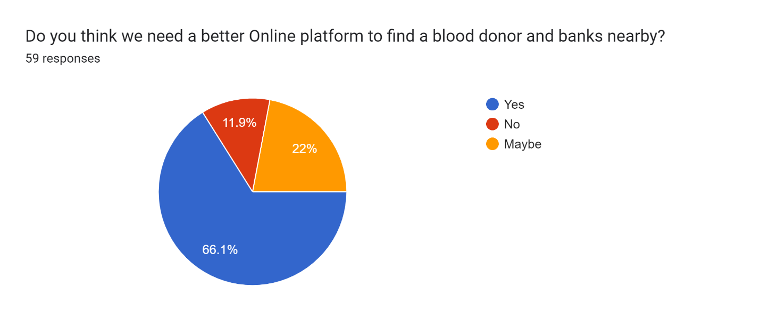

As the survey done by us also say the same, majority of people (66.1%) think that we need a better system related to this matter and 22% of people believe that maybe there must be a better way to provide help in this field.

**Identification of Problem**

Medical science may had been developed till now, but the way the facility reaches to the patients had remained same because of which some patients who can be saved at that fraction of time also gets an unnecessary death. In today’s world everything is online and has an efficient way to server people by their service but medical is the only field which seem to be fall out of this race of development in terms of reaching to the needed ones.

And even if the facilities are provided, they are not so good enough to provide users a simple interface and ease to use that interface.

The major cause of death is because of unavailability of blood or lack of awareness related to the blood transfusion. Even though if the blood is arranged there are some issues with the blood or with the donor which can be life threatening to the patients.

While finding the compatible blood some common issues are face by the individual:

* Availability of blood nearby.
* Compatibility issues in blood.
* Lack of awareness about nearby donors.
* No online medium to check nearby availability.
* No direct interact with donor provided.

These problems are mostly faced because of no online medium availability to find the donor of blood groups needed nearby the location of a recipient.

Some real examples of Blood use in daily bases in India:

|  |  |
| --- | --- |
| Types of cases | Amount of blood required |
| Automobile Accident | *50 units of blood* |
| Heart Surgery | *6 units of blood / 6 units of platelets* |
| Organ Transplant | *40 units of blood / 30 units of platelets* |
| 20 bags of cryoprecipitate | *25 units of fresh frozen plasma* |
| Bone Marrow Transplant | *120 units of platelets/ 20 units of blood* |
| Burn Victims | *20 units of platelets* |

**Identification of Task**

Real-time Blood management system is a way to facilitate a person by providing them a way to make the arrangement of the needed blood type required. This is a website which provide an interface to the user through which their problem can be solved in a fraction of seconds.

In this system we had tried to make this interface which will resolve this problem by making them aware about the donors and blood banks near them by using Realtime updates. In the process of making this system there was two major terms to be discussed and these terms are told below further in this document.

The two major work in making this Real time blood management is that must have and easy to understand UI/UX and the second is to have a database connected to it, which will provide the information to the front-end or interface to show the information which is needed by that person/user.

The front page or the landing page of our website will be the information website which will provide a brief introduction about the website and the way we provide user help, after sliding a little below a person will get two option; if a person wants to became a donor or a person is in need of blood. As per their choice the webpage will get refreshed and a webpage with the needed information will get opened.

If a person wants to became a donor, he/she have to fill a form will the essential details like:- First Name, LastName, Email ID, Aadhaar Card ID, Address, Pin code and Mobile Number.

And, if a person needs blood, then there will be an option to fill about the type of blood, he/she want with any specific blood components or whole blood and then the list of the donors near his/her location will get visible and the preferred blood banks.

Sign in will only be compulsory when the person wants to be an Active donor.

About the database from where we fetch the data will get update as per the availability of the blood groups.

The whole backend load is given to the server and the database from where we fetch the data to show the information at the interface/user side.

The webserver will be responsible for performing various tasks like: -

* The webserver is be responsible for performing various tasks like:
* interacting with Front-end for blood donations and requests,
* finding suitable blood for patients
* interacting with the database for insertion of suitable blood donation entries
* rejection of blood donation which come from donor suffering from any blood disease.

The Database included in the backend is responsible for the following operations: -

* Storing data from blood donations
* Has a detail record of all the blood requests
* Stores data about the current inventory of the blood bank.

The major goal of this system is to provide a functioning website to the users, where they find the specific needed blood and the ones who want a platform to help other by donating the blood to the needed ones at their worst times, but the donor must be physically fit to be an active donor.

**Organization of Report**

**{Ankit yahan tum gantt chart oor summary add ker dena}**

**Organization of Report**

In this section we will be providing an overview of our project report. Our project report will be having five major chapters:

1. Introduction

2. Literature Review/Background Study

3. Design Flow/Process

4. Result Analysis and Validation

5. Conclusion and Future Scope

In ***Introduction*** section we are providing the basic idea of our project that what we are expecting our outcomes to be. It also includes the problem identification and client requirement from the real-world scenario which is the base of our idea behind this project.

In ***Literature Review/Background study*** we are going to describe the ideas which we got from the pre-existing project for blood management system and what are the problems and shortcomings in those projects and out of those shortcomings what we will try to implement in our project.

In ***Design Flow and Process*** we are going to choose the Design of our website from the various designs we proposed and will discuss about the facilities we are going to provide in our website. It will also contain the description of flow of our project.

In ***Result Analysis and Validation*** part we will be validating the actual outcomes of our project along with the Limitations of our project. We have also mentioned the difference between what we thought of and what we have created i.e., difference between our actual and expected outcomes.

In Last phase, ***Conclusion and Future Scope***, we will talk over the advancements with which we have concluded it in context of pre-existing projects over this topic. In this phase we will also state about the future research areas for our system.